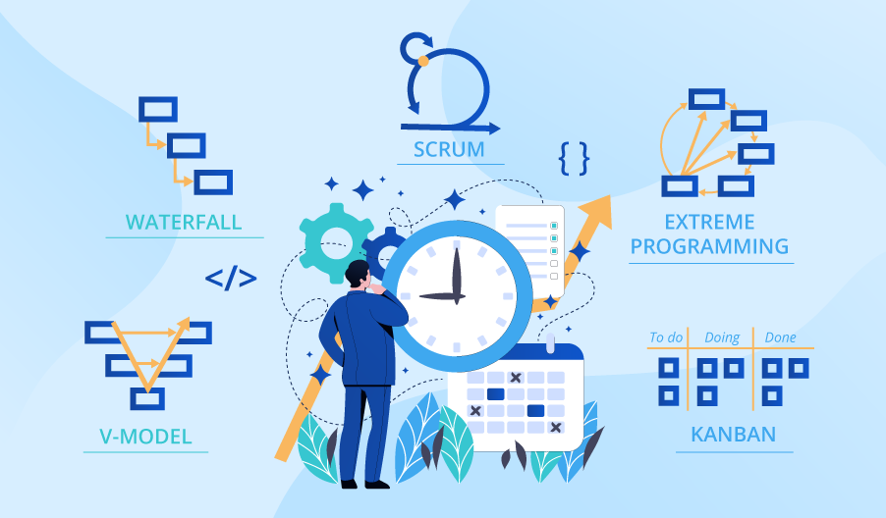

**SE423**

**Software Project Management**

**Activity**

**Activity 3. Lifecycle Planning Activity**

This activity will occur in-class.

Each group will be assigned one of the following models:

* COTS
* Code and Fix
* Waterfall (pure)
* Incremental Development
* Evolutionary Prototyping
* Staged Delivery/Design-to-Schedule
* Agile
* DevOps

For your assigned model, complete the following and be prepared to present to the rest of the class:

1. Draw a representation of the model.
2. What are the major risks of using this model?
3. How is it similar or different from other model?
4. Give an example of where the use of this might be appropriate.

Be sure to include all group member's names in your submission.